1. Write a Python script to list all the prime numbers from 1 to 100 using Sieve of Eratosthenes.

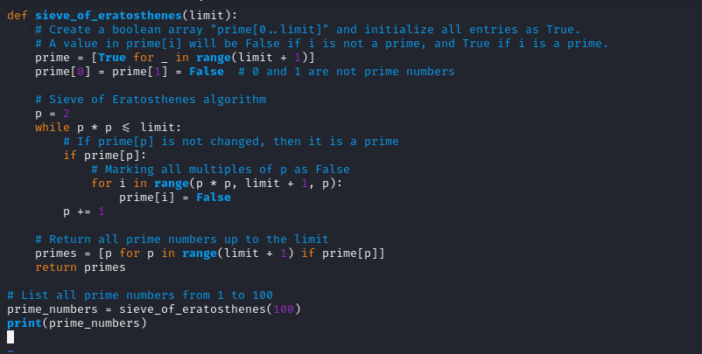

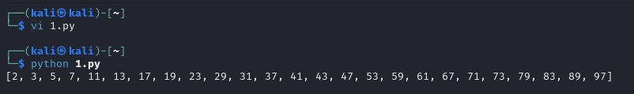

1. Write a Python script to implement RSA algorithm using build in functions (both encryption and decryption)

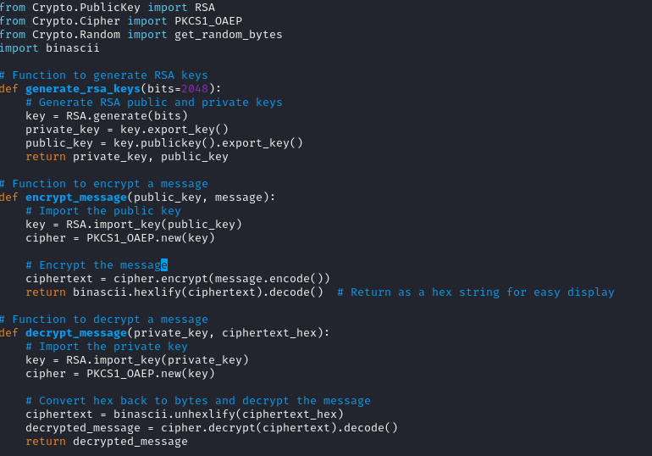

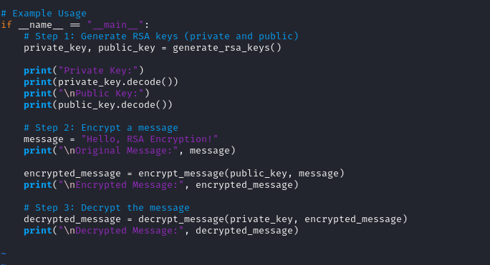

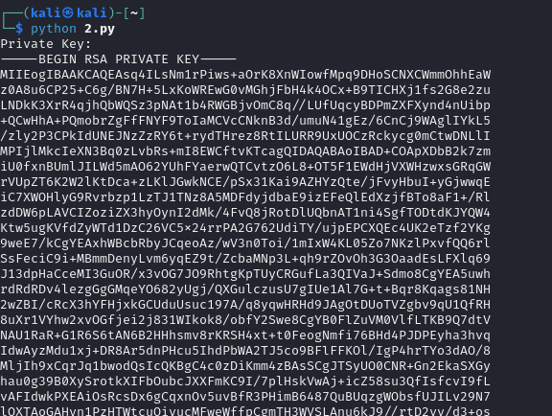

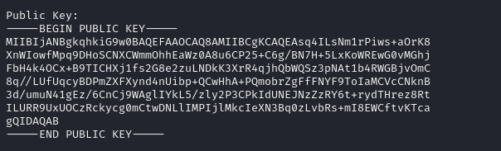







1. Write a Python script to implement RSA algorithm with out using build in functions (both encryption and decryption)

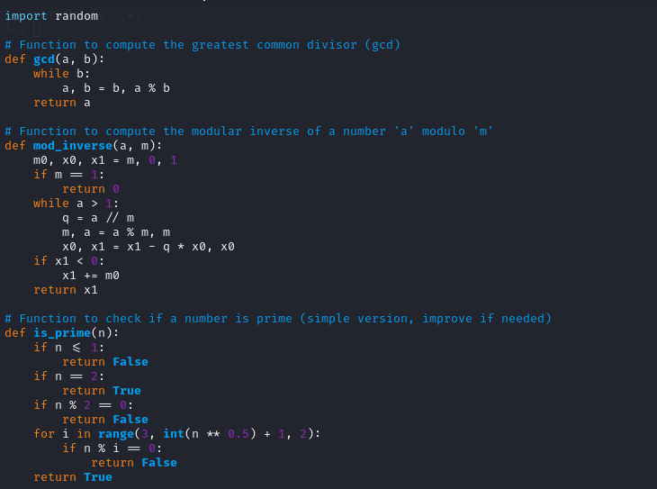

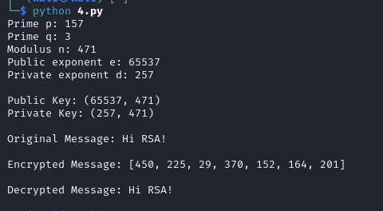

------------------------------------------------------------------------------------------

“Learning is never done without error, and defeat ” – Vladimir Lenin

“There is no substitute for hard work.” – Thomas Alva Edison

“You cannot change your future, but you can change your habits, and surely your habits will change your future.”– A.P.J. Abdul Kalam

---------------------------------------------------------------------------------------------